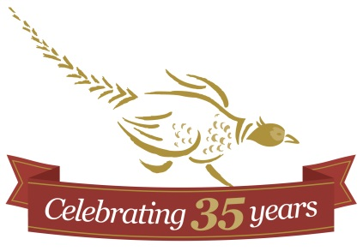
Sample Wedding Timeline

ARRIVAL:
GROOM: 3:00 PM
BRIDE: 20 minutes before or earlier
CEREMONY:
TIME: 4:00 pm
LOCATION: Outdoor Ceremony Area
PHOTOS:
TIME: 4:30 pm – 6:00 pm
LOCATION: On-site around the property
COCKTAILS:
TIME: 4:45 pm – 5:45 pm or 5:00 pm – 6:00 pm
LOCATION: Patio & Tent Area
RECEPTION:
ENTRANCES: 6:00 pm Tent & Dining Area
FIRST COURSE: 6:15/6:30 pm Dining Area
DESSERT AND BAR OPEN: 8:30 pm Tent Area
BAR CLOSES AND MUSIC OFF: 12:30 PM
FACILITY CLOSED: 1:00 AM
SPEECHES: We suggest that speeches are done during dinner service. Our staff will serve and clear as quietly as possible.

